**TITLE OF PROJECT**

**Capstone Project Proposal**

**Submitted by:**

**<102103659>Anipreet Singh**

**<102103678>Saloni Jaroli**

**<102103683>Harshit Rajpal**

**<102103685>Kavya**

**<102103784>Sankalp Gupta**

**BE Third Year-**

**CPG No. 48**

Under the Mentorship of

Dr. Sharad Saxena

Associate Professor



**Computer Science and Engineering Department**

**Thapar Institute of Engineering and Technology, Patiala**

**Jan-Dec,2024**

**TABLE OF CONTENTS**

* Mentor Consent Form <Page No>
* Project Overview <Page No>
* Problem Statement …..
* Need Analysis (1 Page) …..
* Literature Survey (3 Pages) …..
* Research Questions (If Applicable)
* Novelty
* Objectives
* Methodology
* Project Outcomes & Individual Roles
* Work Plan
* Course Subjects
* References

**Mentor Consent Form**

I hereby agree to be the mentor of the following Capstone Project Team

|  |  |  |
| --- | --- | --- |
| **Project Title:** | | |
| **Roll No** | **Name** | **Signatures** |
|  |  |  |
|  |  |  |
|  |  |  |
|  |  |  |

NAME of Mentor: ……… . . . . . . . . . . . . . . . . . . . . . . . . . . . . . . . . . . .

SIGNATURE of Mentor: . . . . . . . . . . . . . . . . . . . . . . . . . . . . . . . . . . . .

NAME of Co-Mentor(if any): ……… . . . . . . . . . . . . . . . . . . . . . . . . . .

SIGNATURE of Co-Mentor: . . . . . . . . . . . . . . . . . . . . . . . . . . . . . . . . . . . .

**Project Overview**

* Complete overview of the capstone project.
* (Max one page-three paragraphs)

**Need Analysis**

* You need to present a short description (One page) of why there is a need for the proposed project and its relevance in the real world.
* You may cite some other existing systems/base research papers (details to be mentioned in the Literature survey) (Optional)

**Literature Survey**

* You need to carry out a detailed survey in your respective field (3 pages).
* Present that literature survey of the systems/products/projects already existing in the real world in this section.

## Research Questions

* [If applicable, outline the research questions that your project aims to answer. These questions should guide your investigation and contribute to the project's overall goals.

**Novelty**

* Highlight the novel aspects of your project that differentiate it from existing solutions or approaches. Explain how your project brings new perspectives, innovations, or improvements to the field.

**Objectives**

* You need to list the objectives (4-5) that you wish to achieve at the end of the capstone project.
* At the end of the final evaluation of the capstone project, these objectives will be used to judge your project completion status.

**Methodology**

* You need to list the methodology of achieving the set objectives, in this section.

**Work Plan**

* You need to give a short work plan which you will set for achieving the set objectives, in this section.
* Sample:-

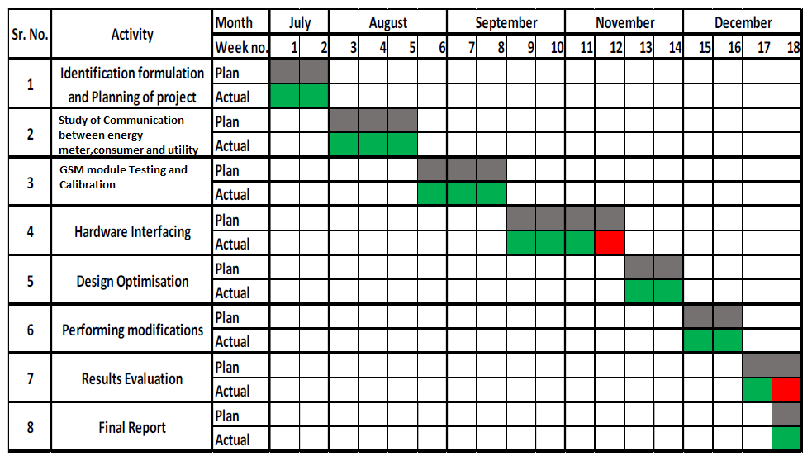

**Project Outcomes & Individual Roles**

* Here, you need to list the outcomes/ products/ systems/ deliverables of your capstone project.
* The individual team member's role must also be specified in this section.

**Course Subjects**

* In this section, you need to list the course subjects that will be used (in the form of conceptual knowledge or practical skills sets) during the successful execution of your capstone project.

**REFERENCES**

**For Journal Paper, Refer this Format:**

|  |
| --- |
| S. No. Surname of First Author of Paper, A. (First Name), Sirname of Second Author of Paper,  (First Name). “Title of paper.” *Name of the Journal*, volume_number, (Issue_No.), Page  Number, date_of_Published (Or Year ofPublished).  Eg:  [1] Anderson T., Peterson L., Shenker S., Turner J.. “Overcoming the Internet impasse  through virtualization.” *IEEE Computer*, vol. 38(4), pp. 34-41, Jan. 26, 2005. |

**For Conference Paper, Refer this Format:**

|  |
| --- |
| S. No. Surname of First Author of Paper, A. (First Name), Sirname of Second Author of Paper,  (First Name). “Title of paper.” In *Title of Published Proceedings*. date_of_Published  (Or Year of Published), Page Number.  Eg:  [1] Smith J., Jones R., Trello K. “Adaptive filtering in data communications with self improved  error reference.” In *Proceedings of IEEE International Conference on Wireless*  *Communications ’04*, 2004, pp. 65-68. |

**For Online Websites, refer this Format:**

|  |
| --- |
| S. No. [citing online websites]  Eg:  [1] Duncan M. (Author(s)) “Engineering Concepts on Ice.” (Website Name) Internet:  [www.iceengg.edu/staff.html](http://www.iceengg.edu/staff.html%20) (Website URL), Oct. 25, 2000 (Date website updated or  published) [Nov. 29, 2023 (date you last accessed the website)]. |

**Formatting Guidelines**

* Project Report Type:  Transparencies and tape-bound
* Number of Copies: 1 per Project group (Max pages 15)
* Running text should be justified, figures and tables center aligned, no space before full stop etc.
* Use **passive voice** in text.
* Paper Size (orientation): A4 (portrait)
* Margins: 1” top / bottom / right and 1.5” left
* Font Type: Times New Roman
* Font Size: 16 bold for Section names, 14 bold for headings and 12 for normal text
* Line Spacing: 1.5 throughout
* Page Numbering:  Bottom center of page in the format – Page 1 of N
* All table and figure captions in size 10 sentence case, table captions on top, and figure captions below the figure.
* All figures and tables quoted in the text with explanation.
* No figures and equations should be copied. Please use **smartdraw/ visio for figures and Mathtype** for equations.
* References (The listing of references should be typed 2 spaces below the heading “REFERENCES” in alphabetical order in single spacing left – justified.  It should be numbered consecutively (in square [ ] brackets, throughout the text and should be collected together in the reference list at the end of the report. The references should be numbered in the order they are used in the text. The name of the author/authors should be immediately followed by the year and other details). References should not be cited from Blogs, Twitter etc. but should refer to good Journal or Conference papers. Typical examples of the references are given below:

**REFERENCES**

[1] Ariponnammal, S. and Natarajan, S. (1994) ‘Transport Phonomena of SmSel – X Asx’, Pramana – Journal of Physics Vol.42, No.1, pp.421-425.

[2] Anderson T. , Peterson L., Shenker S., Turner J.(2005).Overcoming the Internet impasse through virtualization. IEEE Computer, 38(4):34-41.

[3] W. Zeng, H. Yu, C. Lin. (2013, Dec 19). Multimedia Security Technologies for Digital Rights Management [Online]. Available: <http://goo.gl/xQ6doi>. Accessed on [Date]